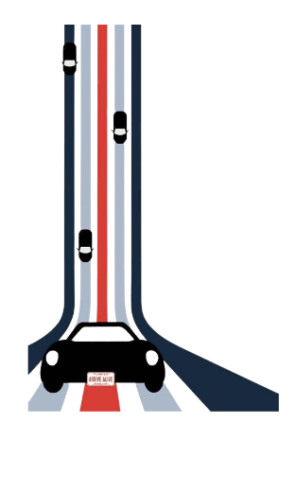
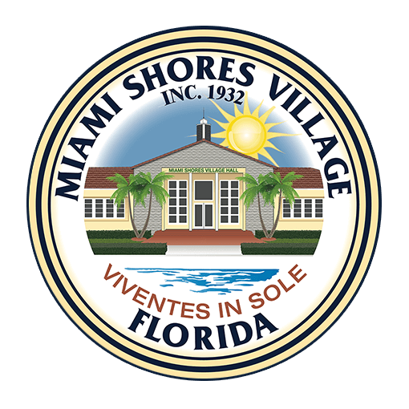
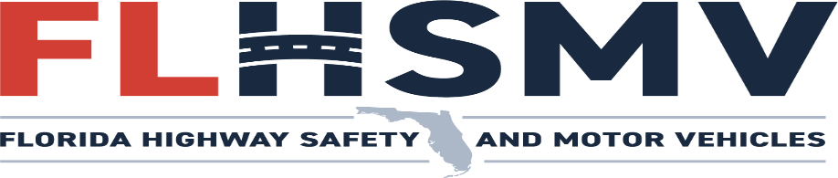

Do you need your Florida Driver’s License or Id Card Renewed or Replaced?

The Department of Highway Safety and Motor Vehicles’ mini-FLOW
(Florida Licensing on Wheels) will be coming to the Miami Shores Community Center. Take advantage of the mini-FLOW program’s team of Driver License Examiners at the Miami Shores Community Center (9617 Park Dr).

Monday August 10, 2026 │10:00am – 1:30pm
Reservation ONLY │ Limited Spots Available

To reserve, contact the Recreation Department at
(305)758-8103. Reservation is first come first service.
Minimum of 35 participants in order to host this service.

Florida Licensing On Wheels mobile offices brings motorist services directly to the customer. FLOW mobiles offer the following services:

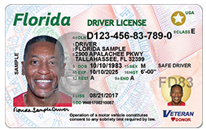
- First time license ($48.00)
- Convert out of state license ($48.00)
- Renewals ($48.00 for Class E; fees vary for CDL)
- Replacements for lost or stolen license ($25.00)
- Address/name changes ($25.00)
- ID cards ($25.00)
- No FEE Poverty Level ID Card.
- Reinstatements (fees vary)
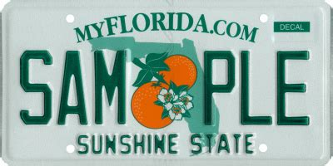
- Emergency Contact Information Registration (free)
- Vehicle Registration Renewals (fees vary)
- Disabled Parking Placard Issuance and Renewals (Permanent- free; Temporary- $15.00)

Obtaining a Florida Driver License or Identification Card

Florida has new documentation requirements for residents renewing or obtaining a driver license or identification card. Please visit www.flhsmv.gov website for a complete listing of documents needed and other information related to obtaining your driver license or ID card.

For your convenience the FLOW Units accepts the following methods of payment:
Cash, Check, and Credit Cards

